Project Initialization and Planning Phase

Date | 6 JULY 2026
Team ID | -
Project Name | AI Powered Debt Relief & Financial Recovery Platform
Maximum Marks | 3 Marks

Define Problem Statements (Customer Problem Statement Template):



Create a problem statement to understand your customer's point of view. The Customer Problem Statement template helps you focus on what matters to create experiences people will love. A well-articulated customer problem statement allows you and your team to find the ideal solution for your customers' challenges. Throughout the process, you’ll also be able to empathize with your customers, which helps you better understand how they perceive your product or service.

Example:
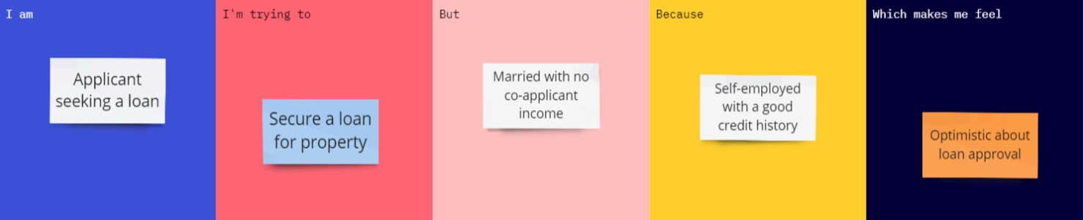

Problem  Statement  (PS) | I am (Customer) | I’m trying  to | But | Because | Which makes me feel
A person struggling with multiple debts | Manage and repay my debts efficiently | I don't know which debt to pay first or how to negotiate with lenders | I lack financial knowledge and personalized guidance | Self-employe d with a good credit history. | Stressed, confused, and worried about my financial future

